**Data Analysis Movies**

1. Calculate the mean and median values for rating

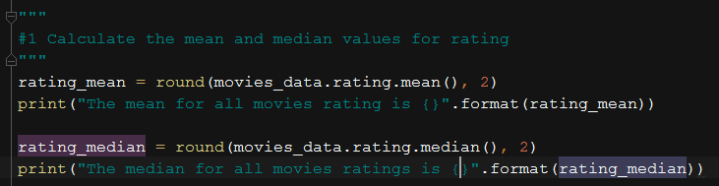



1. According to this dataset, what was the first year that the "PG-13" MPAA rating was issued?

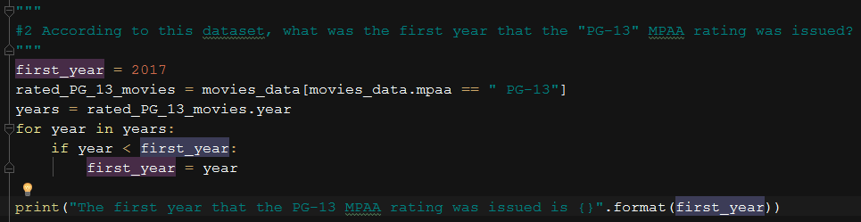



1. For all the movies that have an MPAA Rating (e.g., "PG", "R", etc.), produce a bar chart showing the number of movies in each of these categories

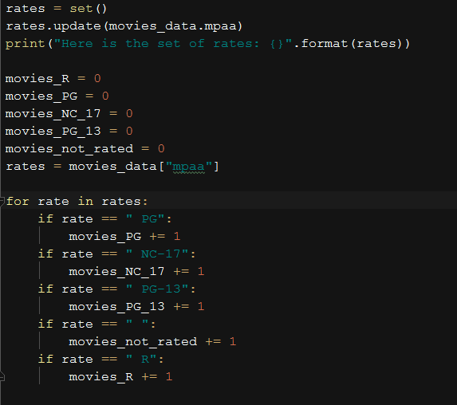 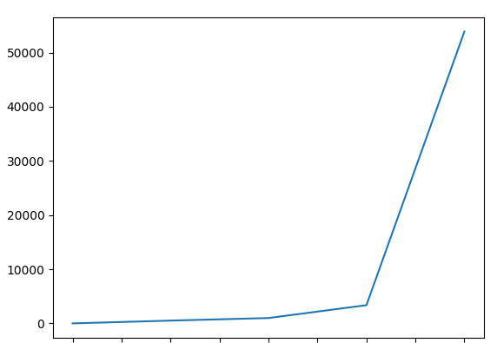

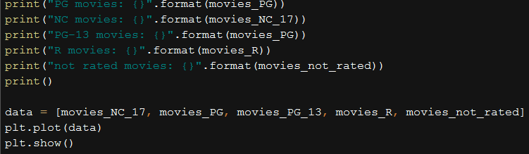

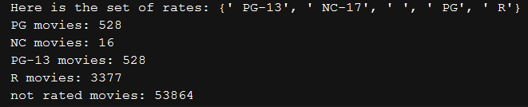

1. Produce a graph showing the number of movies released each year

